INTRODUCTION

The Indian Railway network is the largest rail-passenger transport and it is now the backbone of the country’s transport infrastructure. In India, most of the commercial transport is being carried out by the railway network because it is being cheapest mode of transportation preferred over all other means of transportation such as buses, flights etc. The rapidly improving economy of India has resulted in an exponentially increasing demand for transportation in recent years, and this has resulted into a very huge rise in the volume of traffic in the Indian Railway network. Transport is a key necessity for specialization that allows production and consumption of products to occur at different locations . Economic prosperity has always been dependent on increasing the capacity and rationality of transport. But the infrastructure and operation of transport has a great impact on the land and is the largest resource of energy, making transport sustainability and safety a major issue Transport is very important to carry the passengers and goods from one place to another. The better transport leads to more trade. Economic level is mainly depends on increasing the capacity and level of transport. In this paper we use IR sensor to detect the crack in railroads. The crack is detected then IR sensor is used for the surveying process. This system is designed using ATmega328,IR .

Objectives of the paper

•To detect the cracks present on the railway tracks.

•To detect the obstacles entry on to the railway tracks.

• Brief Methodology

WORKING :

In our project, there are two set of IR sensor units fitted to the two sides of the vehicle The IR transmitter and IR receiver circuit is used to sense the cracks. It is fixed to the front sides of the vehicle with a suitable arrangement. When the vehicle is Powered On, it moves along the model track. The IR sensors monitor the condition of the tracks. In normal condition the motor, LDR, Serial transmission is in initial stage. When the battery power supply supplies the microcontroller then its starting the motor in forward direction and serial transmission is used to send the messages to the microcontroller. When a crack is detected by the IR sensor the vehicle stops at once.

At Normal Condition:

The IR transmitter sensor is transmitting the infrared rays. These infrared rays are received by the IR receiver sensor. The Transistors are used as an amplifier section. At normal condition Transistor is OFF condition. At that time relay is OFF, so that the vehicle running continuously.

At Crack Condition:

At crack detection conditions the IR transmitter and IR receiver, the resistance across the Transmitter and receiver is high due to the non-conductivity of the IR waves. When the track is in continuous without any cracks then output of IR LED and Photodiode will be high. As soon as the crack detected by the system the TSOP sensor reflection will be equal to zero and the robot will be stopped automatically. Another TSOP sensor is used to monitor the pit on the way of the railway track. When this output is high then it is concluded that there is no pit in the track. But if any pit is detected by the sensor the output of the sensor given to the microcontroller will be zero and again the microcontroller will stop the robot. When a crack is detected by the IR sensor the vehicle stops at once.

HARDWARE COMPONENT DESCRIPTION:

The ArduinoUno is a microcontroller board based on the ATmega328 (datasheet). It has 14 digital input/output pins (of which 6 can be used as PWM outputs), 6 analog inputs,16MHz ceramic resonator, a USB connection, a power jack, an ICSP header, and reset button. It contains everything needed to support the microcontroller; simply connect it to a computer with a USB cable or power it with a AC-to-DC adapter or battery to get started. The Uno differs from all preceding boards in that it does not use the FTDI USB-to-serial driver chip. Instead, it features the Atmega16U2 (Atmega8U2 up to version R2) programmed as a USB-to-serialconvertor.

Power

The Arduino Uno can be powered via the USB connection or with an external power supply. The power source is selected automatically. External (non-USB) power can come either from an AC-to-DC adapter (wall-wart) battery. The adapter can be connected by plugging a 2.1mm center-positive plug into the board's power jack. Leads from a battery can be inserted in the GND and Vin pin headers of the POWER connector. The board can operate on an external supply of 6 to 20 volts. If supplied with less than 7V, however, the 5V pin may supply less than five volts and the board may be unstable. If using more than 12V, the voltage regulator may overheat and damage the board. The recommended range is 7 to 12 volts.

Power Supply Circuit;The whole electronic system is depend on the power supply for providing the required power for their operational circuit. For the microcontrollerkeyboard, +5V are required and for operating buzzer +12V is required. The power supply supplied the regulated output of +5V & non-regulated output of the +12V DC supply.

Physical Characteristics

The maximum length and width of the Uno PCB are 2.7 and 2.1 inches respectively, with the USB connector and power jack extending beyond the former dimension. Four screw holes allow the board to be attached to a surface or case. Note that the distance between digital pins 7 and 8 is 160 mil(0.16"), not an even multiple of the 100 mil spacing of the other pins.

Features:

1.Microcontroller-ATmega328

2.Operating Voltage-5V

3.Input Voltage (recommended) -7-12V

4.Input Voltage (limits)-6-20V

5.Digital I/O Pins-14 (of which 6 provide PWM output)

6.Analog Input Pins-6

7.DC Current per I/O Pin-40 mA

8.DC Current for 3.3V Pin-50 mA

9.Flash Memory -32 KB (ATmega328) of which 0.5 KB used by bootloader

10.SRAM -2 KB (ATmega328)

11.EEPROM -1 KB (ATmega328)

12.Clock Speed -16 MHz

IR SENSOR:

An Infrared (IR) sensor is used to detect obstacles in front of the robot or to differentiate between colors depending on the configuration of the sensor.The picture shown is a very simple black box model of the IR Sensor. The sensor emits IR light and gives a signal when it detects the reflected light.An IR sensor consists of an emitter, detector and associated circuitry. The circuit required to make an IR sensor consists of two parts; the emitter circuit and the receiver circuit.The emitter is simply an IR LED (Light Emitting Diode) and the detector is simply an IR photodiode which is sensitive to IR lightof the same wavelength as that emitted by the IR LED. When IR light falls on the photodiode, its resistance and correspondingly, its output voltage, change in proportion to the magnitude of the IR light received. This is the underlying principle of working of the IR sensor.

TSOP OBSTACLE SENSOR:

The TSOP-OBSD–Single is a general purpose proximity sensor. Here we use it for collision detection. The module consist of a IR emitter and TSOP receiver pair. The high precision TSO receiver always detects a signal of fixed frequency. Due to this, errors due to false detection of ambient light are significantly reduced. The module consists of 555 IC, working in astable multivibrator configuration. The output of TSOP is high whenever it receives a fixed frequency and low otherwise. The on-board LED indicator helps user to check status of the sensor without using any additional hardware. The power consumption of this module is low. It gives a digital output and false detection due ambient light is low.

Simple IR Sensor has a disadvantage that it gives false detection when used in presence of sunlight. We can make more complex IR sensor which is able to differentiate between IR light from its own source and sunlight or any other light from surrounding light sources. Here I am going to introduce TSOP based IR Sensor.

BasicIdea:-

In simple IR sensor (link) an IR LED is used to transmit a continuous beam of IR light and a Photo Diode is used to detect reflected light from any surface (surface can be of any obstacle or floor when we are using this sensor in line follower robot). In TSOP based IR Sensor a modulated IR light at selected frequency is transmitted and a receiver is made that would only detect light of the same frequency, filtering out light of other frequencies.

TSOP is a miniaturized receiver for infrared remote control systems. It consists of a PIN diode and a pre-amplifier in a single package. Output of TSOP is active low. As shown in figure ambient light is filtered out by the epoxy package and then the outputof PIN diode is amplified and pass through a band pass filter.TheoutputofTSOPcandirectlybeconnectedbyanyI/Opinofmicrocontroller.There are various TSOP available in market cantered to different frequency.

Circuit of Rx:-

In the above circuit 100 Ω resistance and 4.7μF is connected to suppress power supply disturbances. An LED is connected at the output pin of TSOP to indicate the logic level.

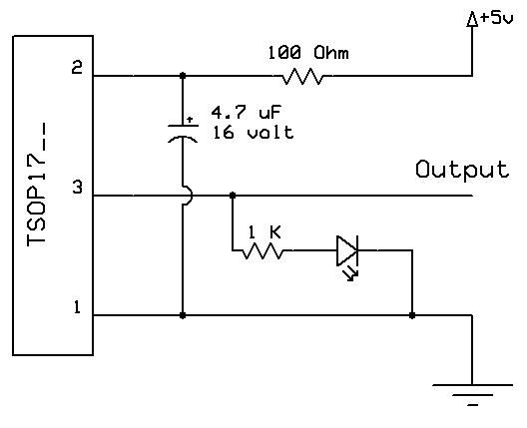

CircuitofTx:-Totransmitlightof36KHzfrequencywecangeneratethatfrequencybyusinganymicrocontroller,oscillatororby555timerIC.Herewehaveusing555timerinastablemodetogenerateasquarewavesignaltodriveanIR-LEDatafrequencyof36KHz.

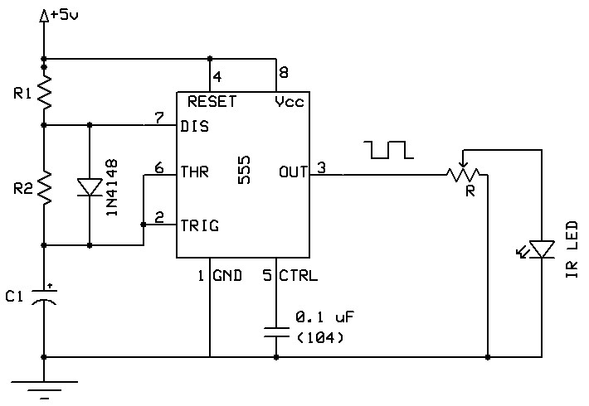

Advantages:

1. Highly efficient and user friendly design.

2. Easy to operate.

3. Low power consumption.

4. To detect the crack using IR obstacle sensors

5. To avoid the accidents at a single track.

8. Efficient design

Applications:

It used in railway departments to reduce the accidents.

CONCLUSION: In this paper we have designed a cost effective, low-power embedded system, which facilitate better safety standards for rail tracks for preventing railway accidents due to cracks and obstacles on railway tracks. The Prototype of testing vehicle can efficiently detect cracks and obstacles on railway tracks. The result shows that this new innovative technology will increase the reliability of safety systems in railway transport. By implementing these features in real time application, we can avoid accidents up to approximately 70%.

Future scope:

Although work can be done in order to provide a better speed to the automated vehicle robot. Also enhancement can be done to get better accuracy about the location of the place where the fault had occurred. Also the robot can be made large so that by using its weight track shiftiness i.e. stress and strain parameters of the track can be determined so as to make this system more effective. A zigbee module can also be incorporated for low cost short distance scrutinizing mechanism in order to provide good connectivity at a low input cost.

REFERENCES:

[1]Selvamraju Somalraju, Vigneshwar Murali, Gourav Saha, Dr.V.Vaidehi, “Robust Railway CrackDetection Scheme (RRCDS) Using LEDLDR Assembly,” IEEE Int. Conf. on Networking, Sensing and Control, vol. 6, iss. 3, pg. 453-460 , May2012 [2].[2]Qiao Jian-hua;Li Lin-sheng; Zhang Jing-gang; “Design of Rail Surface Crack-detectingSystem Based on Linear CCD Sensor,” IEEEInt. Conf. on Networking, Sensing and Control, vol. 14, no. 4, pp. 961-970, April 2008 [3].[3]K. Vijayakumar, S.R. Wylie, J. D. Cullen, C.C. Wright, A.I. Shammaa, “ Non invasive rail track detection system using Microwave sensor,” Journalof App. Phy., vol. 9, iss. 11, pg. 1743-1749, June 2009.[4] Reenu George ,Divya Jose, Gokul T G , Keerthana Sunil , Varun A G,” Automatic Broken Track Detection Using IR Transmitter and Receiver”, International Journal of Advanced Research in Electrical, Electronics and Instrumentation Engineering(IJAREEIE), Volume 4, Issue 4,April 2015.[5] Prof. P.Navaraja, “CRACK DETECTION SYSTEM FOR RAILWAY TRACK BY USING ULTRASONIC AND PIR SENSOR”,International Journal of Advanced Information and Communication Technology (IJAICT) ,Volume -1, Issue-1, May 2014[6] Akhil n, Dinumohan , Fayis p, Sijagopinath,” Railway Crack Detection System”, International Research Journal of Engineering and Technology (IRJET) ,Volume: 03 Issue: 05 | May-2016[7] Rajesh lv, Manjunathgasuti, Mukundaswamy,” CRACK DETECTION AND COLLISION AVOIDANCE IN RAILWAY TRACKS” IRF International Conference,Volume 2,12th June, 2016.[8] Saurabh Srivastava , Ravi Prakash Chaurasia , Syed Imran Abbas , Prashant Sharma, Nitin Kumar Singh,” Railway Track Crack Detection Vehicle” International Advanced Research Journal in Science, Engineering and Technology(IARJSET), Vol. 4, Issue 2, February 2017.

[9] Ajeya G R, Ashwini N,KavithaS,Latha D C, ChaithraG, ”Robust Railway Track Crack Detection Scheme”, International Research Journal of Engineering and Technology (IRJET), Volume: 03 Issue: 05 | May-2016[10]S. Arivazhagan, R. NewlinShebiah, J. Salome Magdalene and G. Sushmitha, “Railway Track Derailment Inspection System Using Segmentation Based Fractal Texture Analysis “Ict Academy Of Tamilnadu(Ictact)Journal On Image And Video Processing, August 2015, Volume: 06, Issue: 01[11]Shrenik S. Sarade , Nikhil D. Chandoba, Manoj R. Sowani , Shishir K. Malusare,” Review of Railway Track FaultFinding System”, International Journal for Research in Applied Science & Engineering Technology(IJRASET) ,Volume 3 Issue X, October 20